144. Directory State in Redux

1. create a directory redux folder

2. create the directory-reducer.js

i. create the directoryReducer

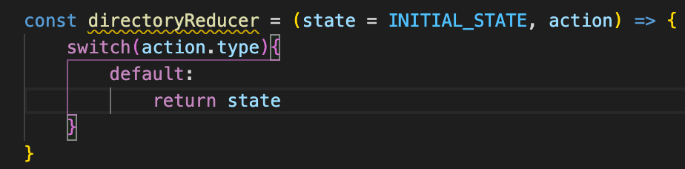

3. Bring in the directoryReducer in root-reducer; then point the directory to the directory-reducer

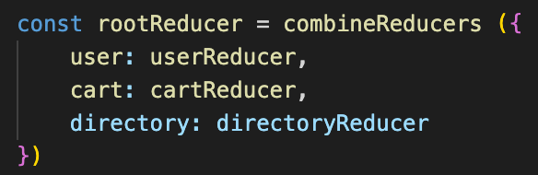

4. pull the state to <Directory />

i. import { connect } from ‘react-redux’

ii. change the class <Directory /> to functional as there’s no need to declare the state locally

iii. remove the local state

iv. pull the sections as props

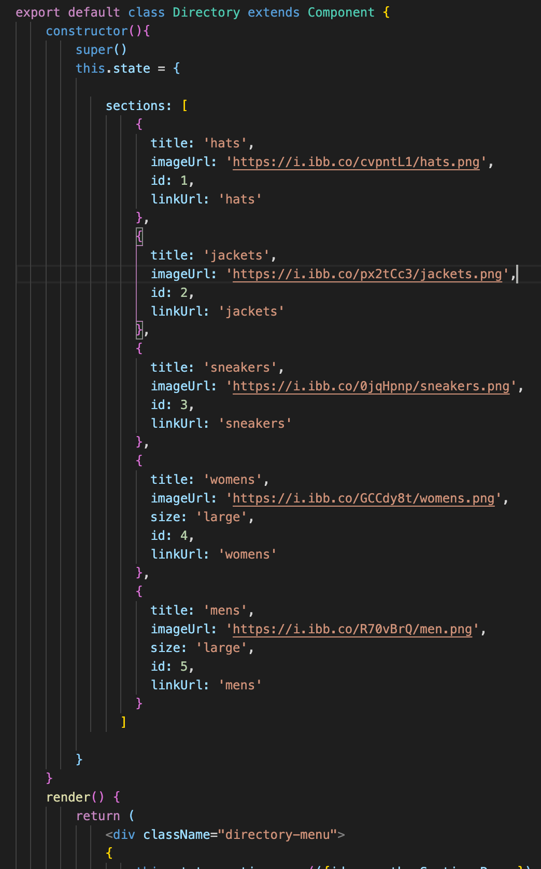 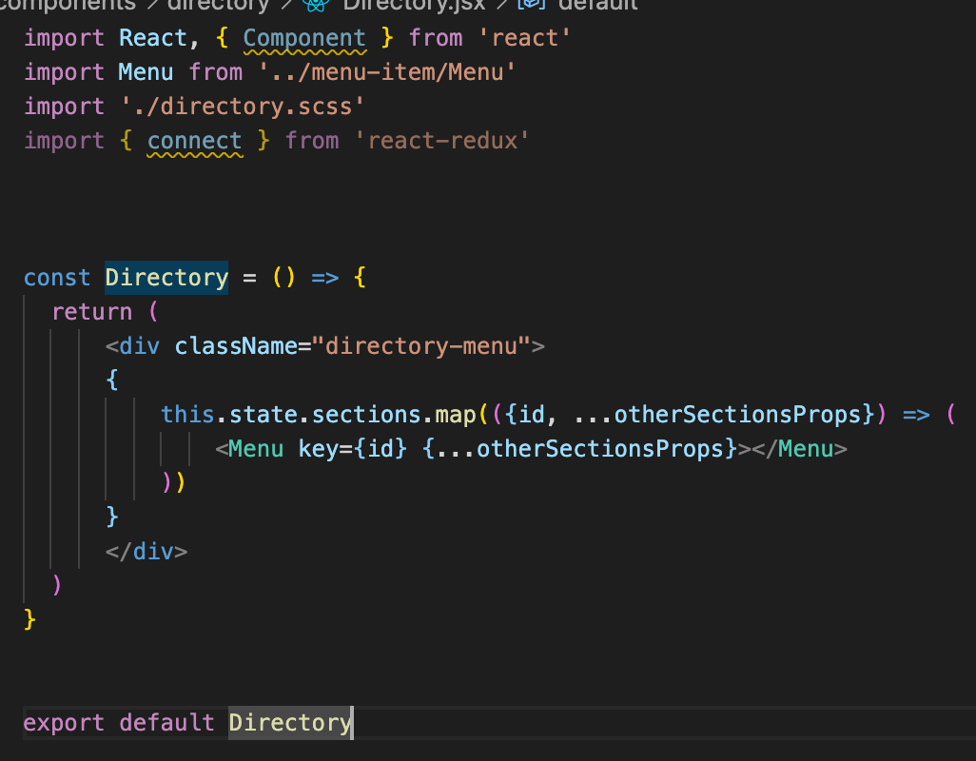

v. Create the mapStateToProps

const mapStateToProps = createStructuredSelector( sections: selectDirectorySections )

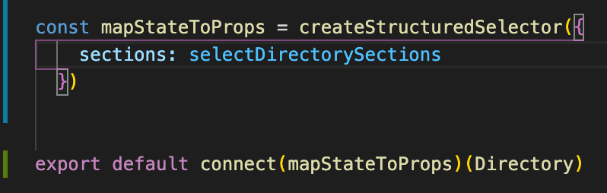

vi. Create the directory-selector.js

1. Create the selectDirectorySections

2. bring this into <Directory />

3. import { selectDirectorySections }

4. import { createStructuredSelector } from ‘reselect’



vii. remove the this.state in the <Directory />

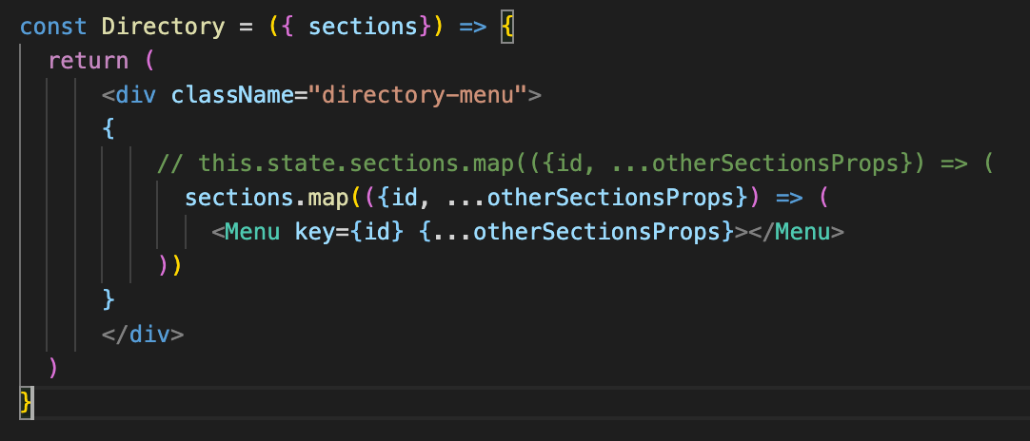

145. Colllection State to Redux

a. create shop directoryand shop-selector.js and bring in the shop.data.js to shop directory

b. transfer the SHOP_DATA from shop.data.js to shop-reducer.js. export default shopReducer

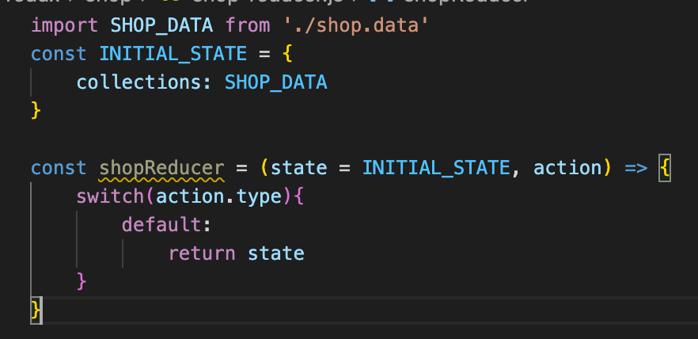

c. bring in shop: shopReducer to root-reducer

d. create the shop-selector.js

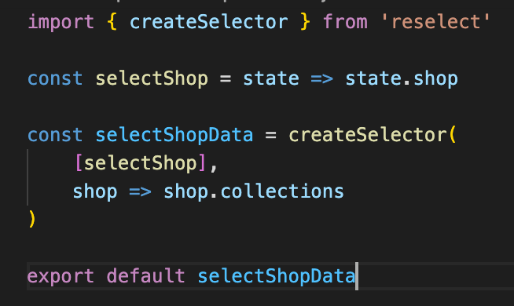

d. convert class <Shoppage /> to functional component

1. import { connect }

2. import [ shop }

3. import { createStructuredSelector }

4. import { shopSelectorData }

3. create mapSTateToProp=createStructuredSelector({ shop: shopSelectorData })

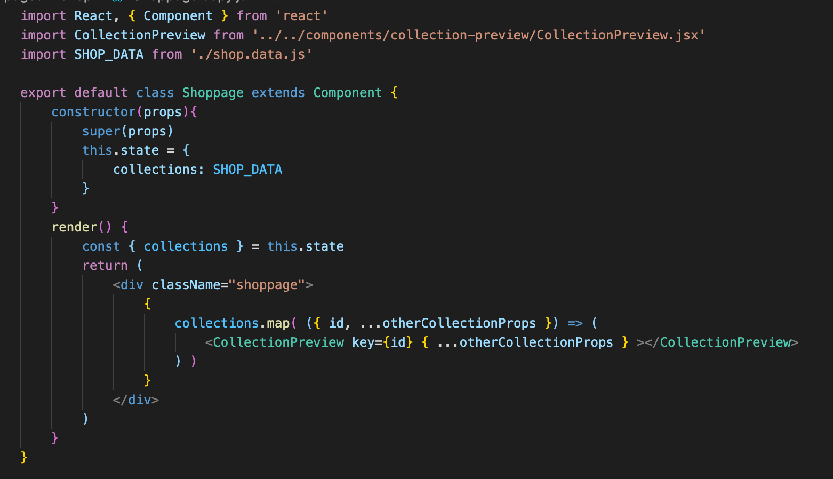 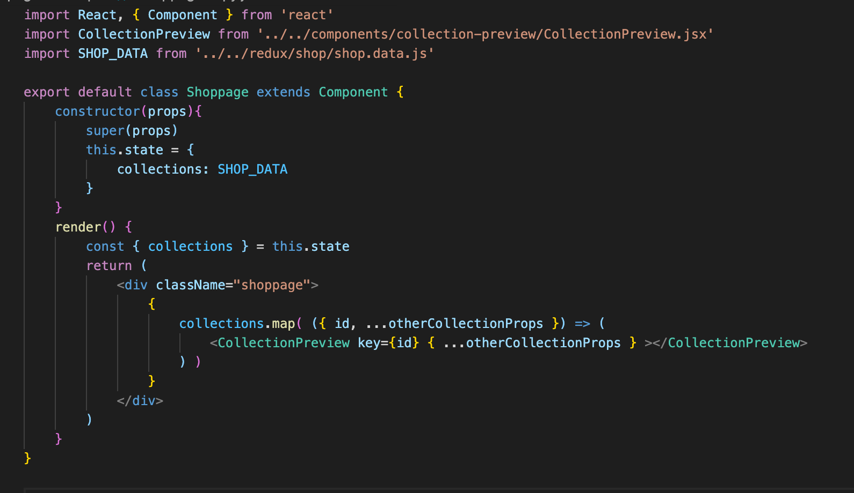

146. Collection overview component

a. move the collections to its own component which is currently utilized In Shoppage.jsx. This is same as the cartItems

b. create collections-overview folder and its corresponding files

1. get the contents of the div of the <Shoppage /> and put it in <CollectionPreviews />

2. remove the connect() in Shoppage.jsx

c. <Shoppage /> will only be like as below afterwards. Just import the <CollectionOverViews />

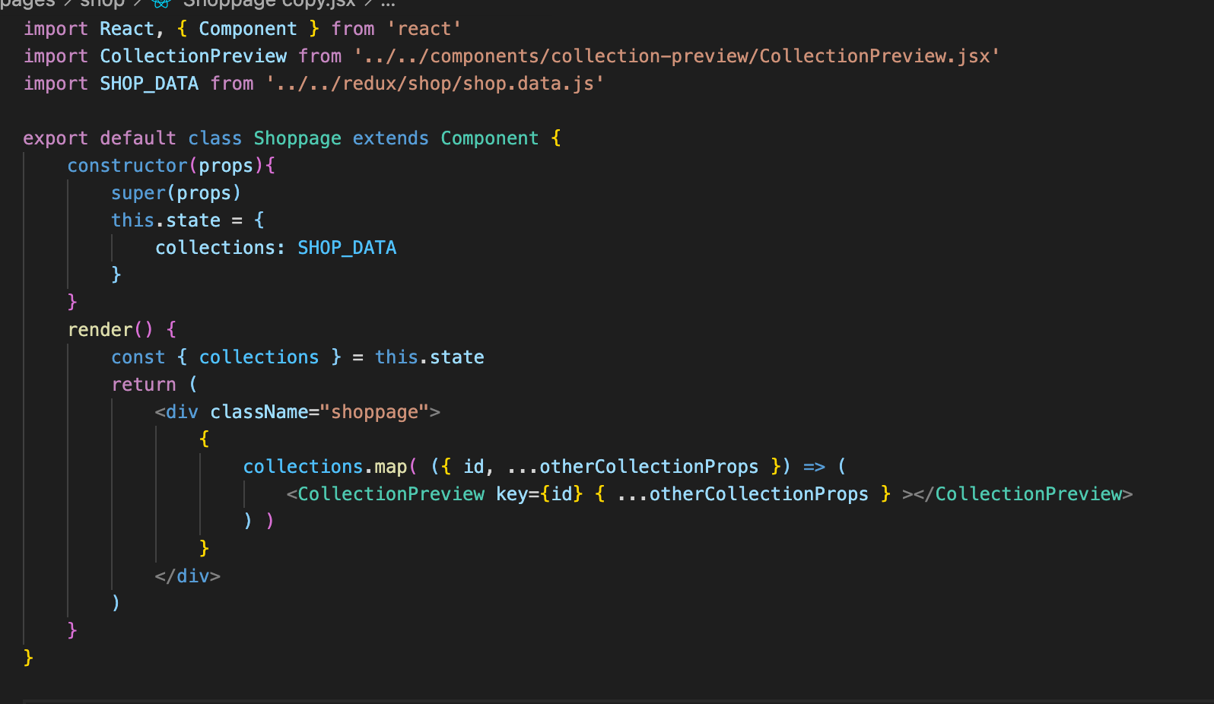 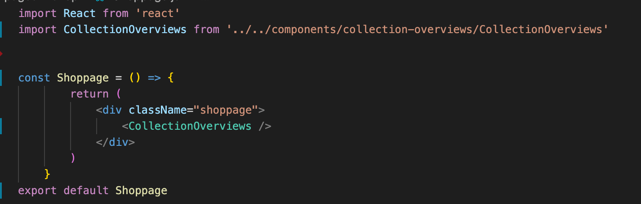

d. <CollectionOverviews /> as below

